Project Two Micro Service Integration with Database

# Required Software

Vagrant: <https://www.vagrantup.com/>

Java 8: <http://www.oracle.com/technetwork/java/javase/downloads/jdk8-downloads-2133151.html>

Eclipse or STS: <https://www.eclipse.org/> OR <https://spring.io/tools/sts>

Maven: <https://maven.apache.org/>

Postman: <https://www.getpostman.com/apps>

MySQL Workbench: <https://dev.mysql.com/downloads/workbench/>

# Needed Code

The db Folder from the <https://github.com/xpanxion/xhire-spring-bootcamp> github repo

# Setup

We will use vagrant to create a VM that has the db running on it with a pre-defined database and some basic data.

## Run Vagrant

1. Open a command line and navigate to the db folder of the git repo.
2. Run vagrant up in your command line and wait for that to finish. It will create a new VM with Cent OS and install MaraiaDB on the VM. The DB will be available from localhost:4406 with a username of root and password of root.

## Setup the Workbench

It will be good to setup the MySQL work bench to be able to access our database so we can verify that things are working as expected.

1. Open the workbench  
   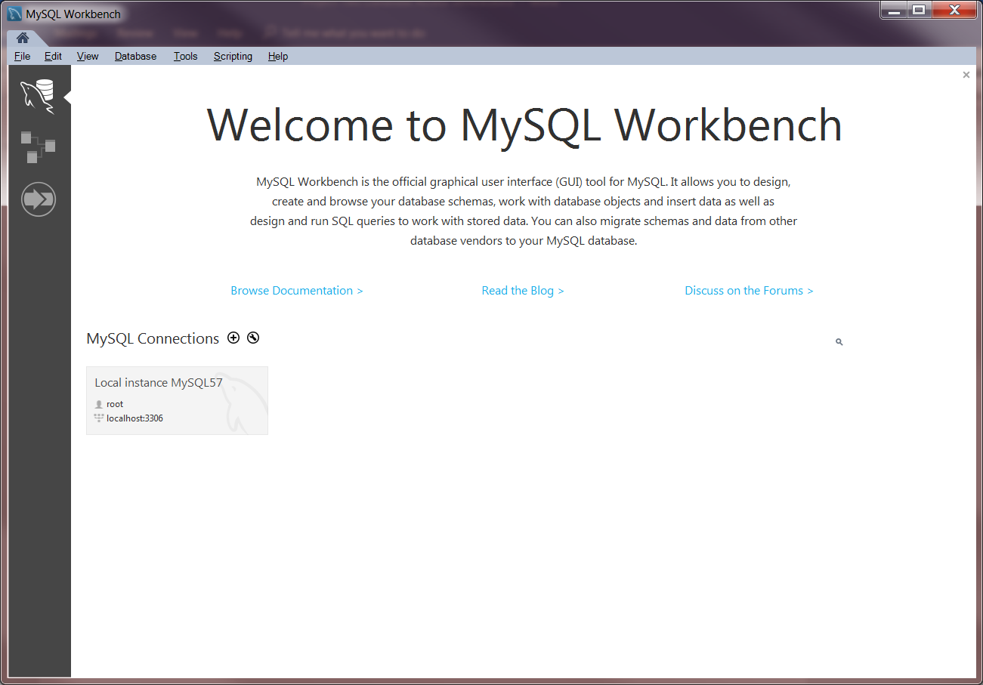
2. Click the + button next to the MySQL Connections label  
   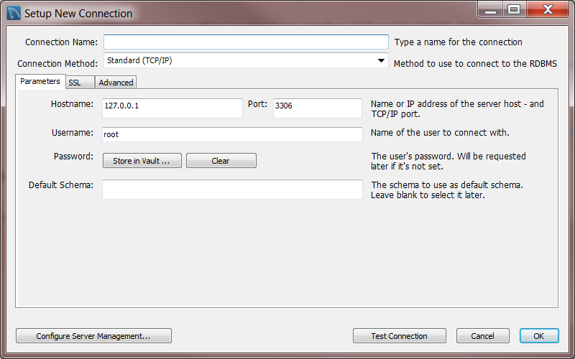
3. Enter in a connection name, change the port to 4406  
   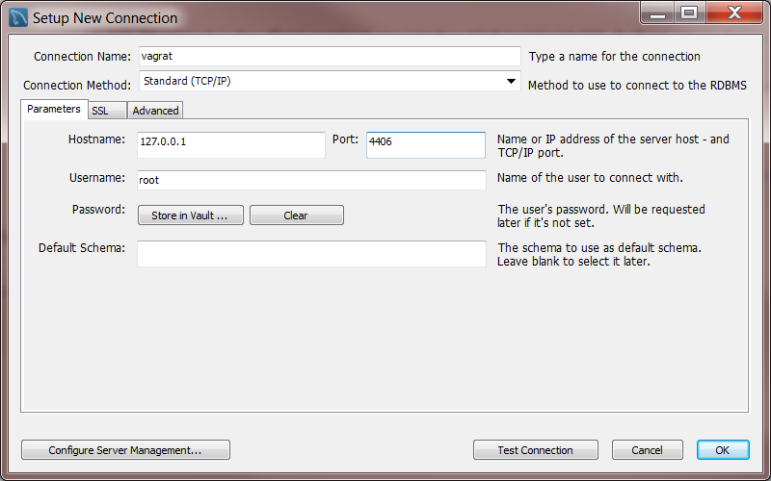
4. Click the Store in Vault … button for the password  
   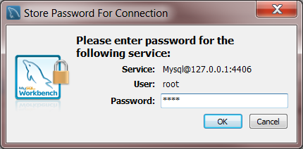
5. Type in root and press ok then press Test Connection in the main box. You should see a response such as   
   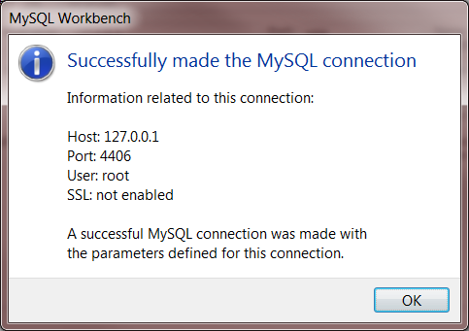
6. Click ok and then ok and you should see your connection available in the main screen  
   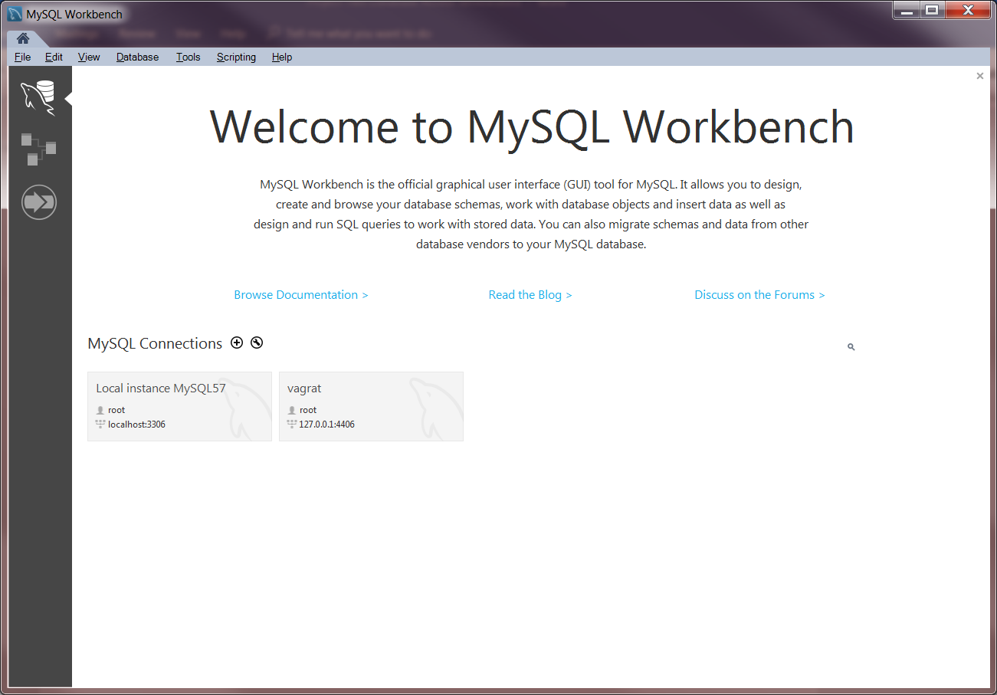
7. Click on the connection and it should open up the workbench connected to your db.   
   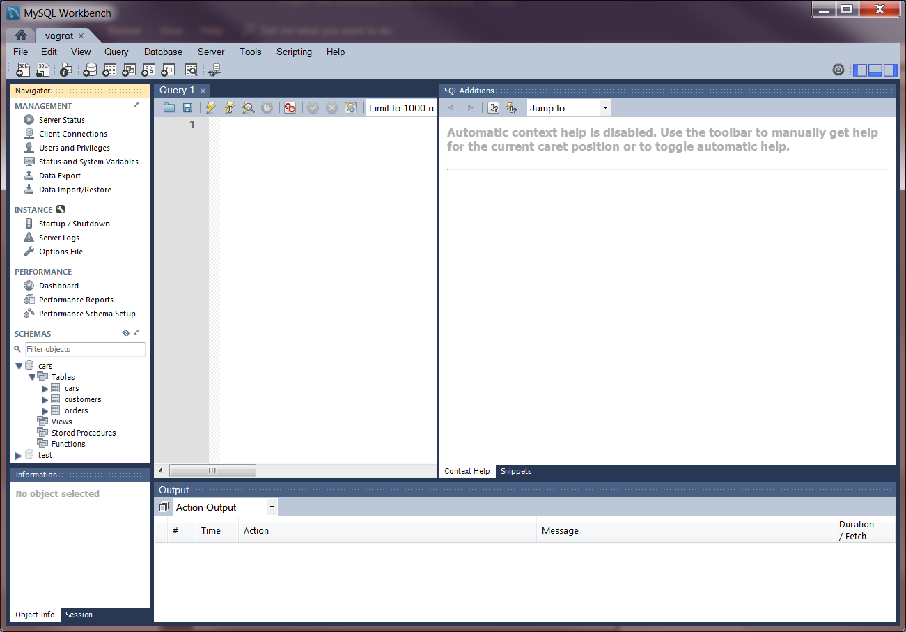

On the left you can verify in the schemas section that you have a cars schema with 3 tables cars, customers and orders.

# Project Requirements

We have a database structure as shown in the diagram below our goal is to implement CRUD operations available via Rest Services.

